**EMO Website Documentation**

**Project Information**

* **Project Name**: EMO (Empowerment, Mindfulness, and Optimism)
* **Team Name and Members**:
  + Katelyn Coming
  + Joeroz A. Vicariato
  + Pauline May Coming
* **Institution**: Northern Bukidnon State College
* **Submission Date**: [Insert Submission Date]

**Table of Contents**

1. **Introduction**
   * Purpose
   * Scope
   * Overview
2. **System Description**
   * Background
   * Goals
   * Features
3. **Requirements**
   * Functional Requirements
   * Non-functional Requirements
   * Technical Requirements
4. **Design**
   * Wireframes or Mockups
   * Database Design
   * Architecture
   * User Interface (UI) Design
5. **Implementation**
   * Development Process
   * Code Snippets
   * Challenges and Solutions
6. **Testing**
   * Test Cases
   * Feedback
7. **User Manual**
   * How to Access
   * Navigation Guide
   * Troubleshooting
8. **Conclusion**
9. **Appendices**
10. **References**

**1. Introduction**

**Purpose**  
The EMO website aims to empower students by providing resources and tools to help them understand and manage their emotions effectively. It serves as a platform for emotional tracking and education.

**Scope**  
The target audience includes students, educators, and anyone interested in improving their emotional intelligence. Potential use cases include tracking moods, accessing emotional resources, and engaging with a supportive community.

**Overview**  
This documentation provides a comprehensive guide to the EMO website, detailing its purpose, features, design, implementation, testing, and user instructions.

**2. System Description**

**A. Background**  
The EMO website addresses the growing need for emotional well-being resources among students. Research indicates that emotional intelligence is crucial for academic success and interpersonal relationships.

**B. Goals**  
The website aims to achieve:

* User convenience in tracking emotions
* Increased accessibility to emotional health resources
* Enhanced understanding of emotional intelligence

**C. Features**

* **Mood Tracking**: Users can log their current mood and view statistics.
* **Quote Generation**: Provides motivational quotes.
* **Responsive Design**: Accessible on various devices.
* **Gallery and Team Section**: Visual representation of emotional well-being and introduction to the team.

**3. Requirements**

**A. Functional Requirements**

* Users can select and save their mood.
* Users can generate and view motivational quotes.
* Users can view mood statistics in a chart format.

**B. Non-functional Requirements**

* The website must load in under 3 seconds.
* It should be scalable to accommodate a growing user base.
* The website must be reliable and available 99% of the time.

**C. Technical Requirements**

* **Software**: HTML, CSS, JavaScript, Bootstrap, Chart.js
* **Hardware**: Any device with a modern web browser
* **Hosting**: Live server for deployment
* **Browser Compatibility**: Chrome, Firefox, Safari, and Edge

**4. Design**

**A. Wireframes or Mockups**  
*Insert wireframes or mockups of the website layout here.*

**B. Database Design**  
*Insert a diagram of tables and relationships if applicable.*

**C. Architecture**  
The website follows a Model-View-Controller (MVC) architecture, separating the data model, user interface, and control logic.

**D. User Interface (UI) Design**

* **Color Scheme**: Blue and white for a calming effect.
* **Typography**: Arial for readability.
* **Navigation Structure**: A sticky navigation bar for easy access to sections.

**5. Implementation**

**A. Development Process**

1. **Planning**: Define goals and features.
2. **Design**: Create wireframes and mockups.
3. **Development**: Code the website using HTML, CSS, and JavaScript.
4. **Testing**: Conduct usability testing and fix issues.
5. **Deployment**: Launch the website on a live server.

**B. Code Snippets**

html

Copy code

<!-- Mood Tracking Form -->

<form class="d-flex" role="search">

<input class="form-control me-2" type="search" id="appletSearchBar" placeholder="Search..." aria-label="Search">

</form>

This snippet shows the search bar used for mood tracking.

**C. Challenges and Solutions**

* **Challenge**: Ensuring cross-browser compatibility.
* **Solution**: Tested the website on multiple browsers and adjusted CSS styles accordingly.

**6. Testing**

**A. Test Cases**

| **Test Scenario** | **Expected Result** | **Actual Result** |
| --- | --- | --- |
| User saves a mood | Mood is logged successfully | Mood logged successfully |
| User generates a quote | A new quote is displayed | A new quote is displayed |

**B. Feedback**  
Feedback from users indicated a need for clearer instructions on mood tracking, leading to updates in the user manual.

**7. User Manual**

**A. How to Access**

To access the EMO website, open a web browser and navigate to :  
<https://medcaree.github.io/CompanyWeb/>

**WEB INTRODUCTION SECTION:  
  
HOME**

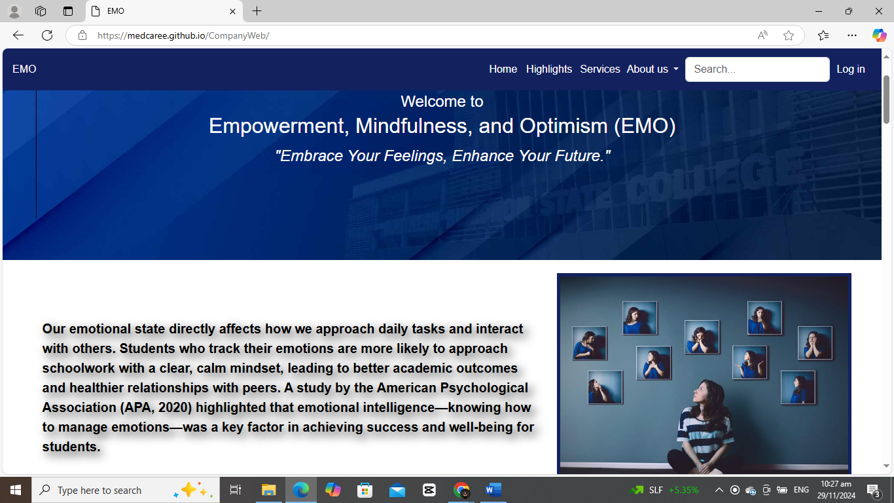

**HIGHLIGHTS**

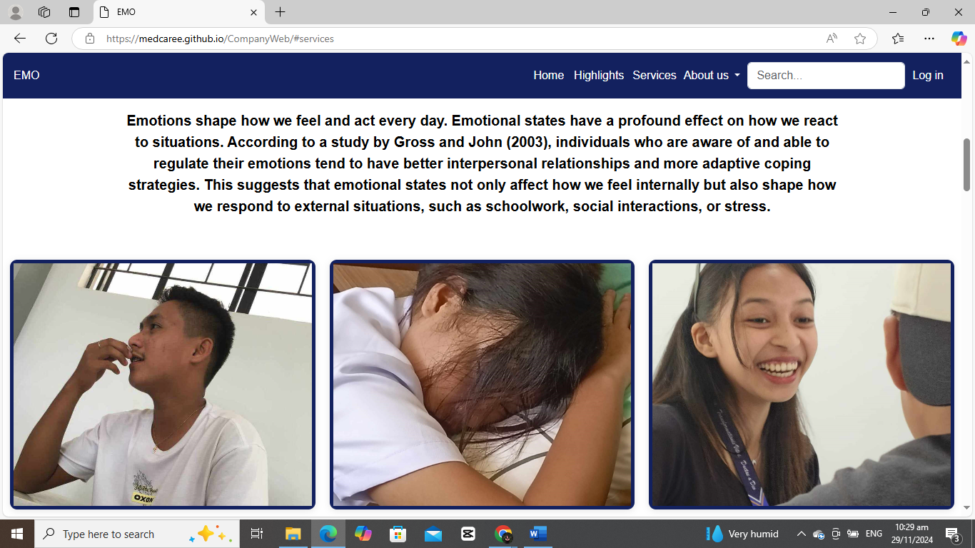

**SERVICES**

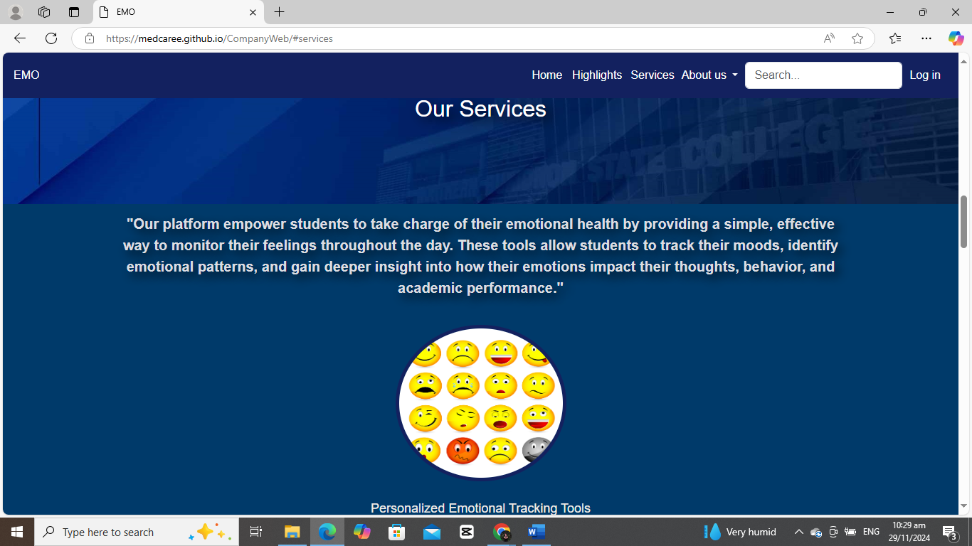

**ABOUT US**

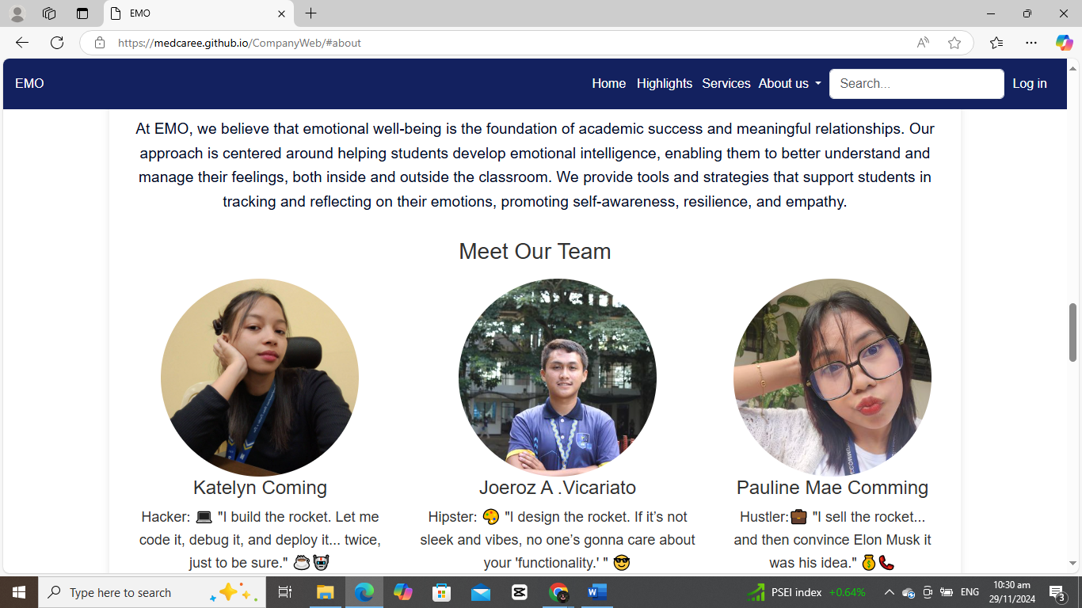

**VISION AND MISSION**

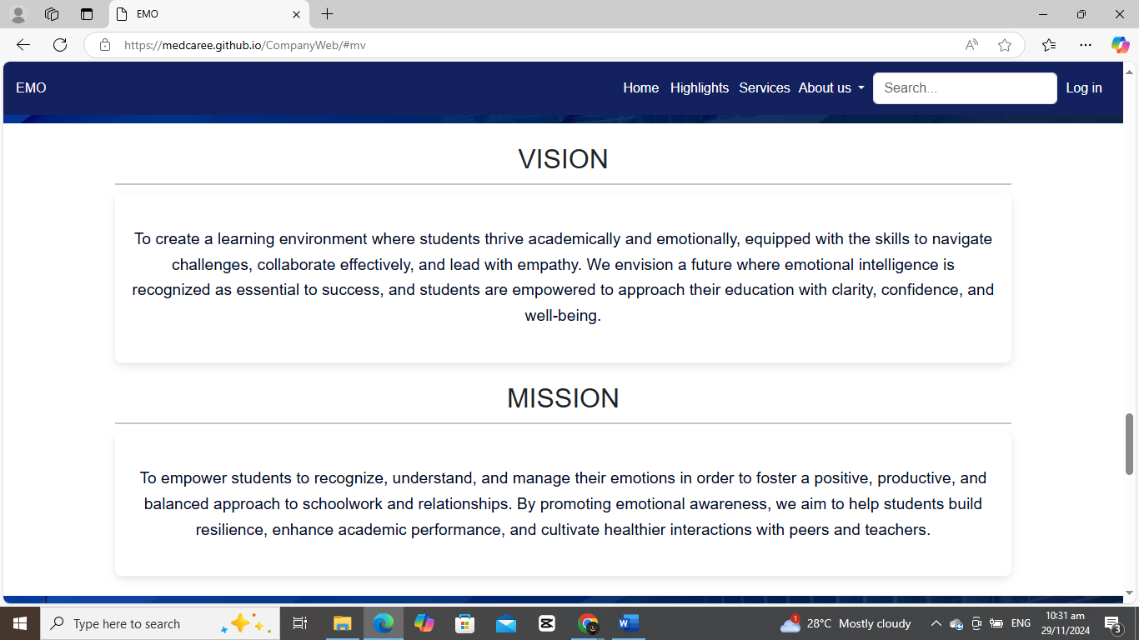

**CONTACT US**

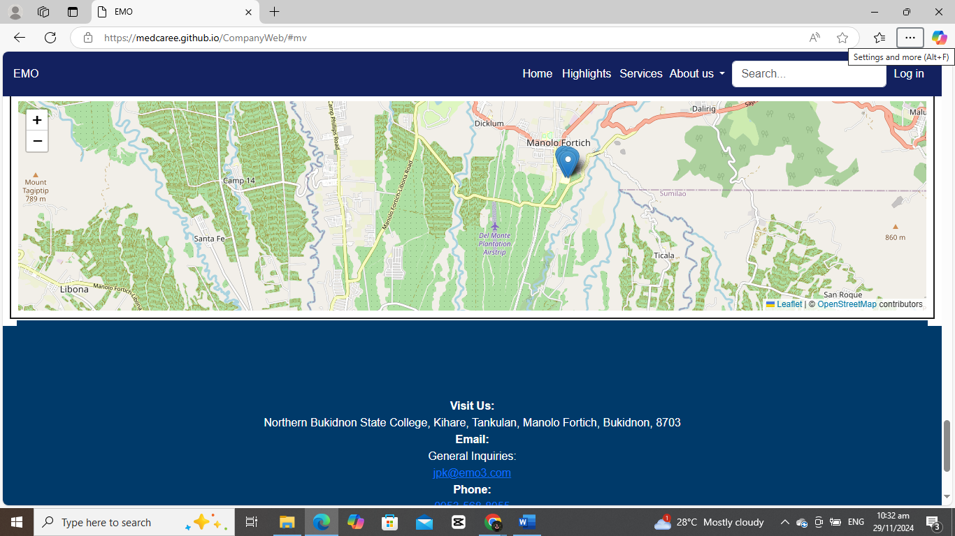

**LOG IN**

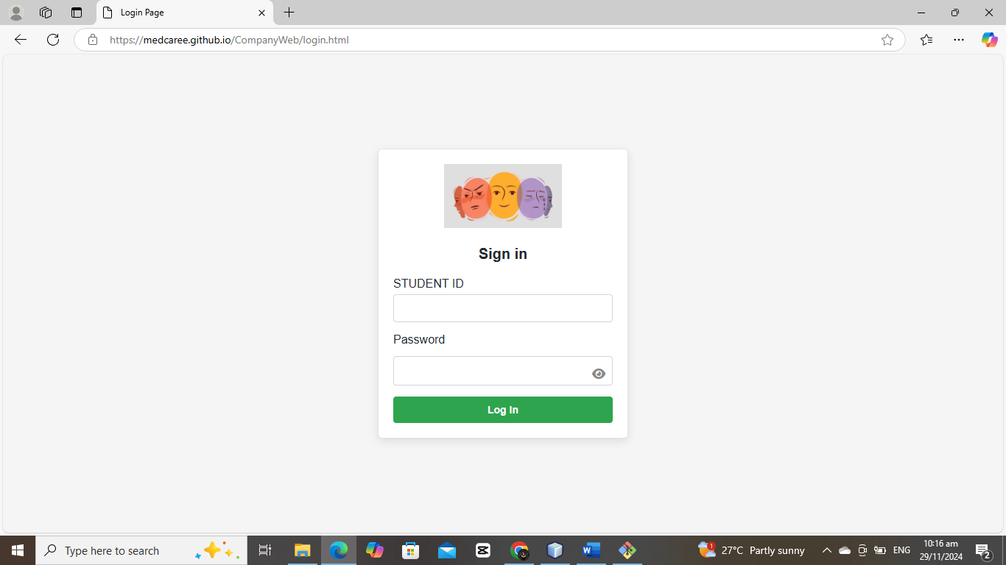

**HOMEPAGE**

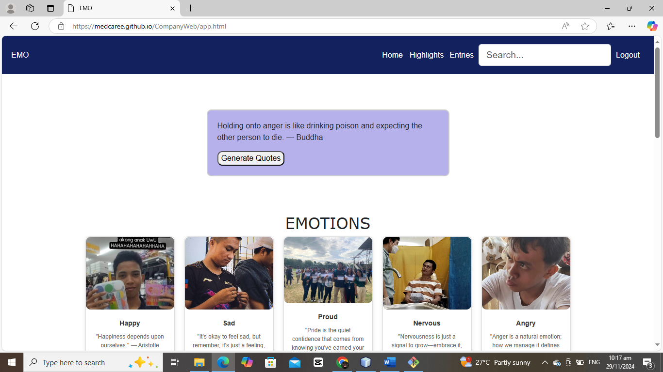

**HOMEPAGE HIGHLIGHTS**

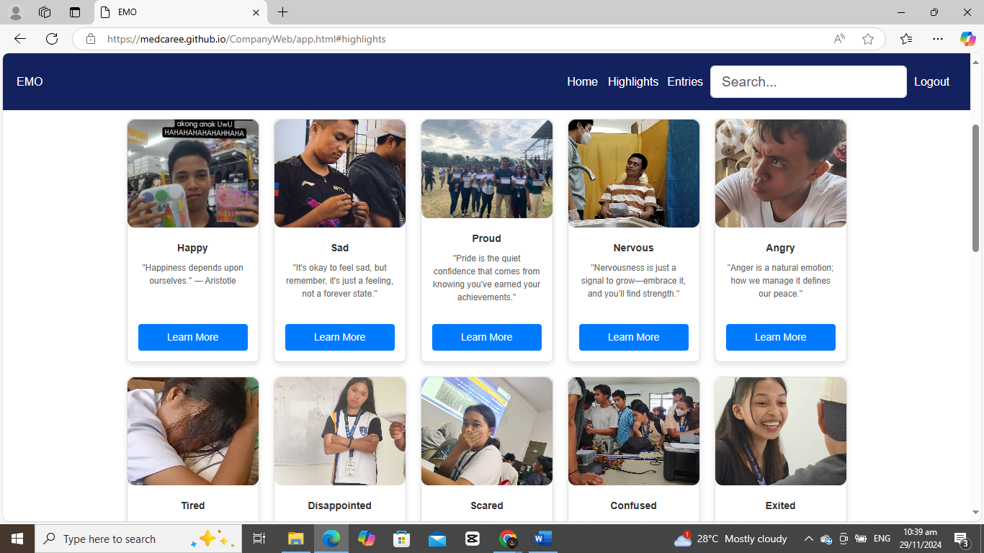

**ENTRIES**

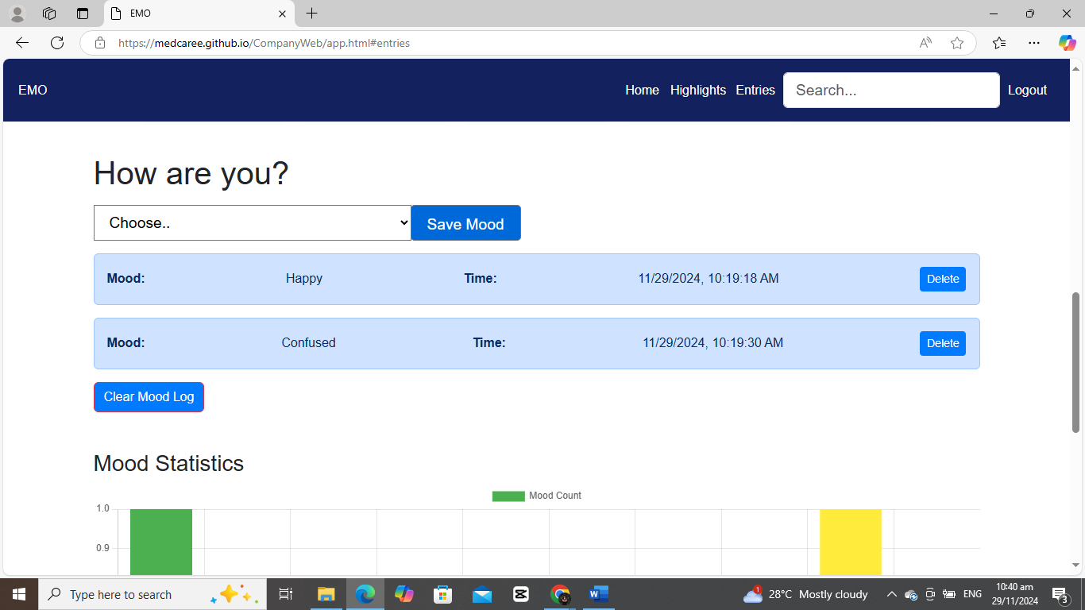

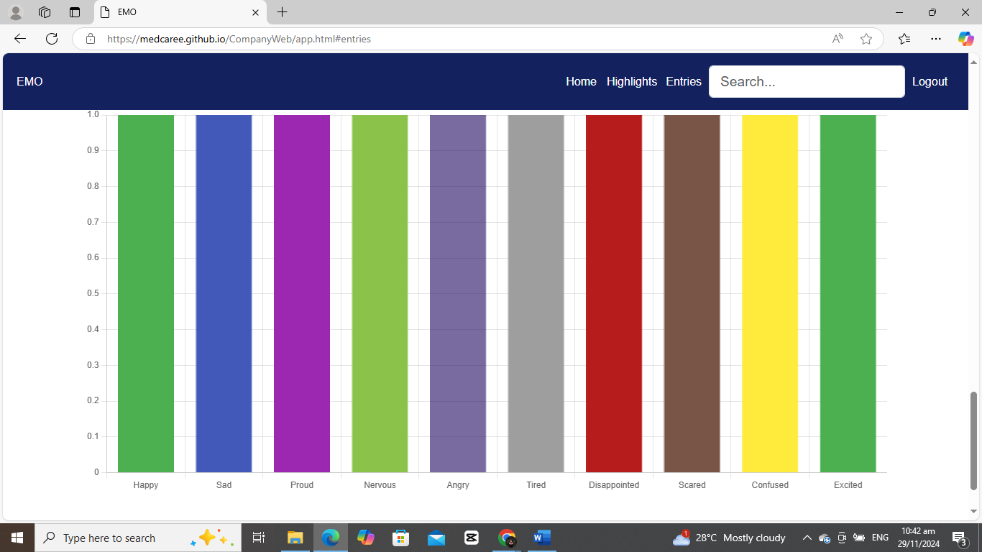

**B. Navigation Guide**

* Use the navigation menu to access different sections.
* Select your mood from the dropdown and click "Save Mood."
* View mood statistics in the chart section.

**C. Troubleshooting**

* **Issue**: Mood not saving.  
  **Solution**: Ensure a mood is selected before clicking "Save Mood."

**8. Conclusion**

The EMO website successfully provides a platform for emotional well-being, helping students track their emotions and access valuable resources. Future plans include adding more interactive features and expanding the content library.

**9. Appendices**

*Insert any additional diagrams or data here.*

**10. References**

* Research articles on emotional intelligence.
* Tutorials and documentation for HTML, CSS, and JavaScript.